Oxford Scholarship Online (OSO)

URL：http://www.oxfordscholarship.com/
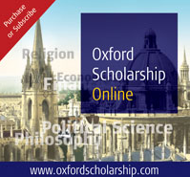
About OSO：Oxford Scholarship Online is a vast and rapidly expanding cross-searchable library which now offers quick and easy access to the full text of 3,726 Oxford books in 18 subject areas- Biology, Business and Management, Classical Studies, Economics and Finance, History, Law, Linguistics, Literature, Mathematics, Music, Neuroscience, Philosophy, Physics, Political Science, Psychology, Public Health and Epidemiology, Religion and Social Work. Combining excellence with innovation, Oxford Scholarship Online is a unique and invaluable tool for both research and teaching.

Feature:
- Keywords and abstracts at both book and chapter level, the vast majority written by the original author.
- Reference linking from bibliographies and footnotes to available online content, such as journals from a wide range of publishers.
- COUNTER-compliant statistics.
- Printer-friendly format for easier printing.
- Automatically export citations to ProCiteTM, EndnoteTM, Reference ManagerTM and RefWorksTM.
- Digital object identifiers (DOIs) at book and chapter level make Oxford Scholarship Online ideal for online course packs and reading lists.

